* [**Count the number of facilities**](https://pgexercises.com/questions/aggregates/count.html)

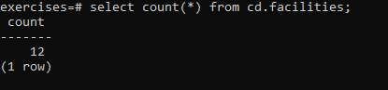

* [**Count the number of expensive facilities**](https://pgexercises.com/questions/aggregates/count2.html)

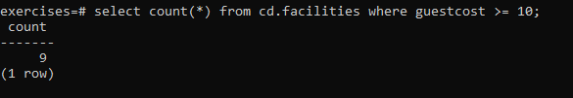

* [**Count the number of recommendations each member makes.**](https://pgexercises.com/questions/aggregates/count3.html)

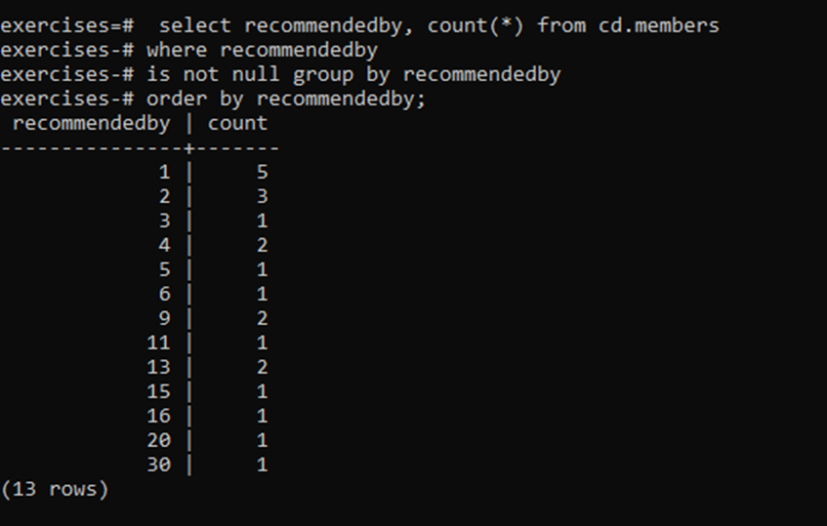

* [**List the total slots booked per facility**](https://pgexercises.com/questions/aggregates/fachours.html)



* [**List the total slots booked per facility in a given month**](https://pgexercises.com/questions/aggregates/fachoursbymonth.html)

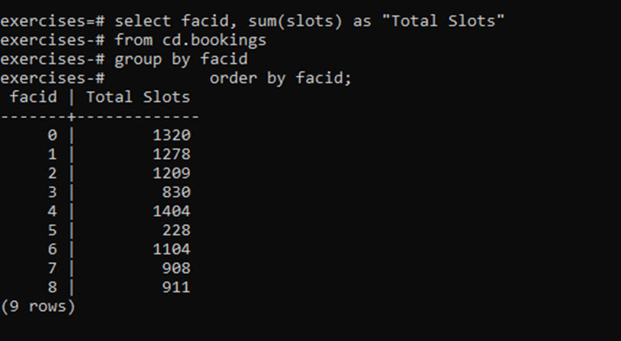

* [**List the total slots booked per facility per month**](https://pgexercises.com/questions/aggregates/fachoursbymonth2.html)



* [**Find the count of members who have made at least one booking**](https://pgexercises.com/questions/aggregates/members1.html)

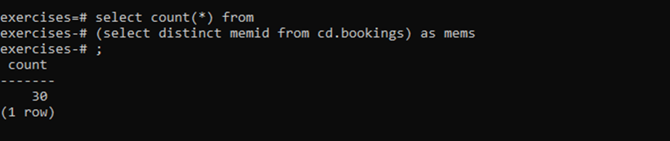

* [**List facilities with more than 1000 slots booked**](https://pgexercises.com/questions/aggregates/fachours1a.html)

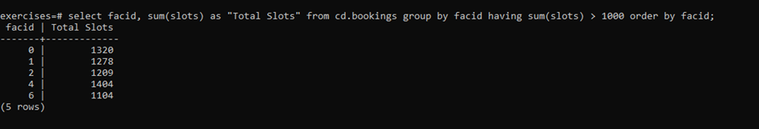

* [**Find the total revenue of each facility**](https://pgexercises.com/questions/aggregates/facrev.html)

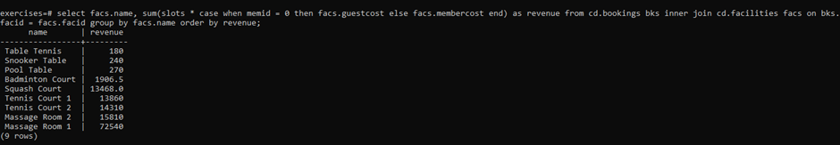

* [**Find facilities with a total revenue less than 1000**](https://pgexercises.com/questions/aggregates/facrev2.html)
* 
* [**Output the facility id that has the highest number of slots booked**](https://pgexercises.com/questions/aggregates/fachours2.html)

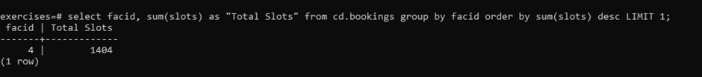

* [**List the total slots booked per facility per month, part 2**](https://pgexercises.com/questions/aggregates/fachoursbymonth3.html)

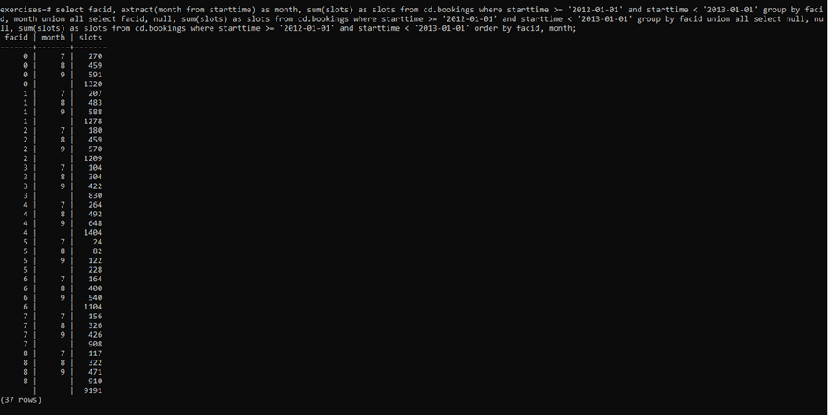

* [**List the total hours booked per named facility**](https://pgexercises.com/questions/aggregates/fachours3.html)



* [**List each member's first booking after September 1st 2012**](https://pgexercises.com/questions/aggregates/nbooking.html)

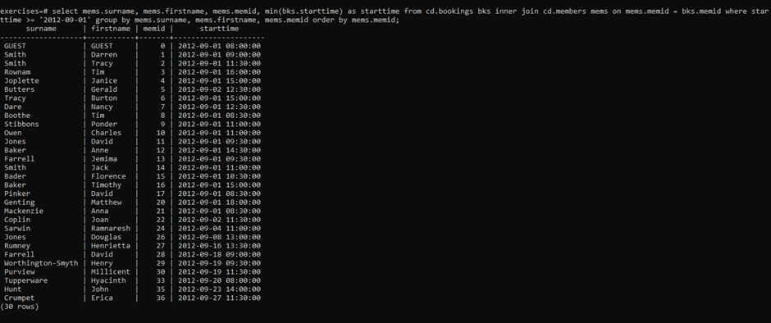

* [**Produce a list of member names, with each row containing the total member count**](https://pgexercises.com/questions/aggregates/countmembers.html)

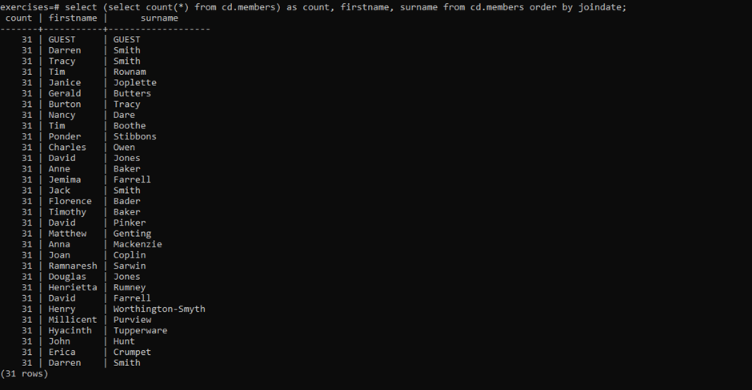

* [**Produce a numbered list of members**](https://pgexercises.com/questions/aggregates/nummembers.html)

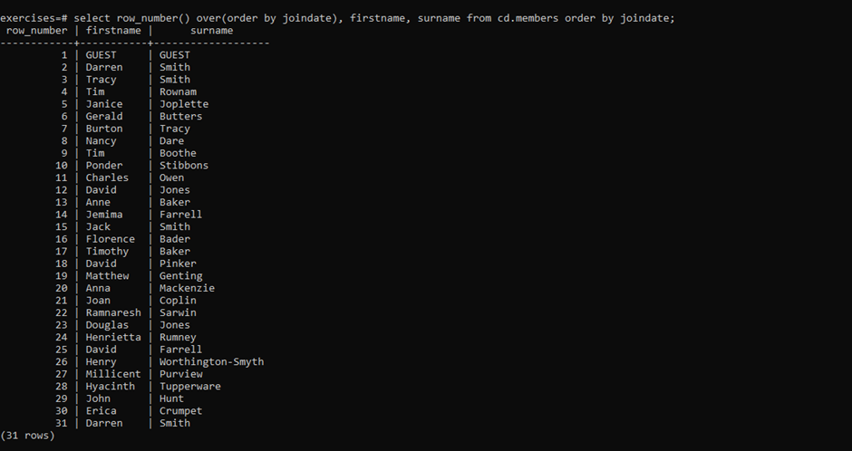

* [**Output the facility id that has the highest number of slots booked, again**](https://pgexercises.com/questions/aggregates/fachours4.html)



* [**Rank members by (rounded) hours used**](https://pgexercises.com/questions/aggregates/rankmembers.html)

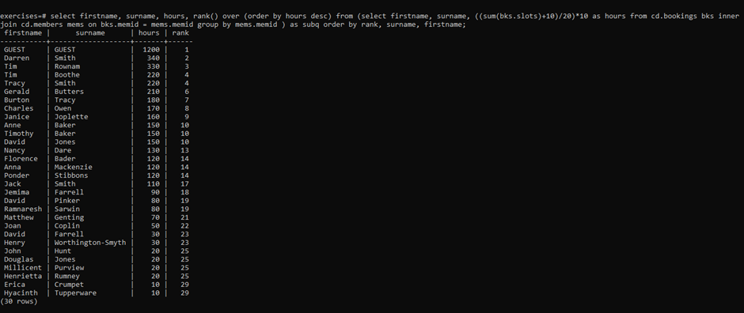

* [**Find the top three revenue generating facilities**](https://pgexercises.com/questions/aggregates/facrev3.html)

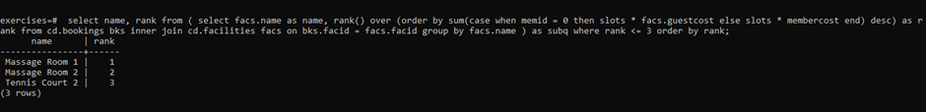

* [**Classify facilities by value**](https://pgexercises.com/questions/aggregates/classify.html)

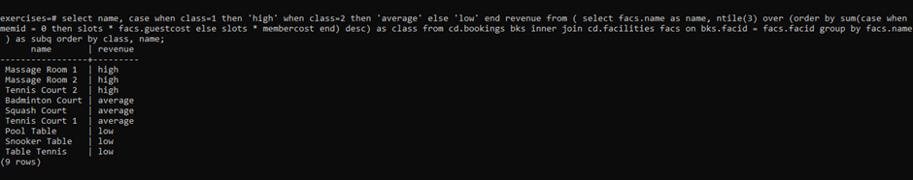

* [**Calculate the payback time for each facility**](https://pgexercises.com/questions/aggregates/payback.html)

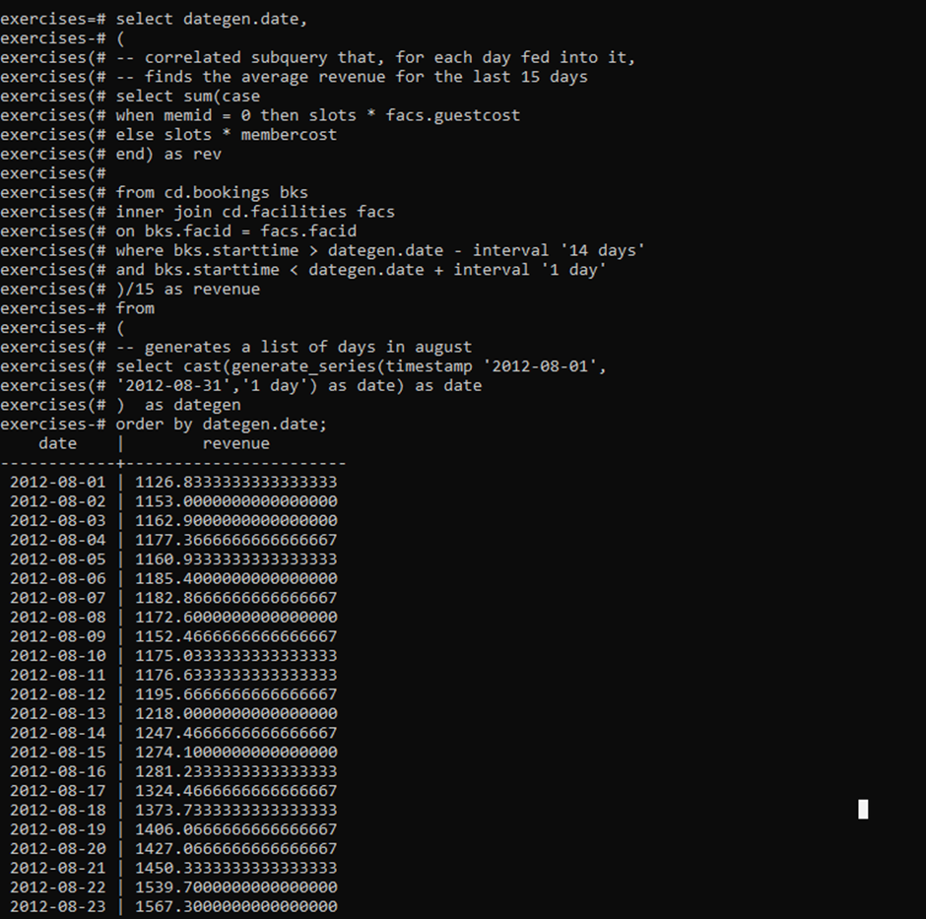

[**Calculate a rolling average of total revenue**](https://pgexercises.com/questions/aggregates/rollingavg.html)

